Project Report

On

**IOT NETWORK SECURITY**

Submitted in partial fulfilment of the requirements for the award of

**BACHELOR OF TECHNOLOGY**

**in**

**COMPUTER SCIENCE & ENGINEERING**

(Artificial Intelligence & Machine Learning)

by

**Ms. B.PADMASRI (22WH1A6632)**

**Ms. A.PRASHANTHI (22WH1A6638)**

**Ms. B.NIVEDA (22WH1A6642)**

**Ms. P.HARSHINI (22WH1A6660)**

**Under the esteemed guidance of**

**Ms. P Anusha**

**Assistant Professor, CSE(AI&ML)**



**Department of Computer Science & Engineering**

**(Artificial Intelligence & Machine Learning)**

**BVRIT HYDERABAD COLLEGE OF ENGINEERING FOR WOMEN**

**(AUTONOMOUS)**

**(Approved by AICTE, New Delhi and Affiliated to JNTUH, Hyderabad)**

**Accredited by NBA and NAAC with A Grade**

**Bachupally, Hyderabad – 500090**

2024-25

**ABSTRACT**

This project introduces a lightweight encryption technique tailored for secure communication in Internet of Things (IoT) networks. Recognizing the constraints of IoT devices, such as limited computational power and memory, the program employs an XOR-based encryption method to demonstrate secure message exchange. By encrypting and decrypting data efficiently, this approach emphasizes minimal computational overhead, making it suitable for resource-limited environments. The implementation simulates a secure messaging system, adhering to key security principles such as data confidentiality and reversible encryption. Through simplicity and effectiveness, the project showcases foundational concepts of IoT security while addressing the challenges posed by constrained devices. While the XOR-based encryption method offers a straightforward and computationally light solution, its simplicity also highlights inherent vulnerabilities, making it unsuitable for real-world applications requiring robust security. However, this limitation serves as a learning opportunity, illustrating the trade-offs between security strength and resource efficiency in IoT systems. Ultimately, the project underscores the critical importance of secure data exchange in IoT environments and provides a practical introduction to encryption mechanisms. By focusing on core principles and basic implementations, it serves as a stepping stone for understanding more advanced encryption techniques necessary for real-world IoT security applications.

**PROBLEM STATEMENT**

**Title**: Ensuring Secure Communication in IoT Networks Using Lightweight Encryption Techniques

The rapid expansion of Internet of Things (IoT) devices has heightened the need for secure communication protocols to protect sensitive data transmitted over networks. However, many IoT devices operate under significant resource constraints, limiting their ability to support computationally intensive encryption methods. This project tackles the challenge by implementing a lightweight XOR-based encryption mechanism, designed to ensure secure communication with minimal computational overhead. The XOR-based approach is tailored for resource-constrained environments, offering a simple yet effective method for encrypting and decrypting data. By simulating message exchanges in an IoT network, the solution ensures data confidentiality by rendering transmitted messages unintelligible to unauthorized parties. The reversible nature of XOR encryption allows for efficient data recovery while maintaining computational efficiency. Though the simplicity of this technique makes it unsuitable for high-security real-world applications, it highlights key encryption concepts critical for IoT communication. This project emphasizes the trade-offs between resource efficiency and security robustness, providing a foundation for understanding more advanced encryption methods.

**Functional Requirements**

1. **Monitoring**:
   * The system must monitor IoT device traffic, bandwidth usage, and device health in real-time.
   * Track metrics such as latency, packet loss, and throughput specifically for IoT devices and sensors.
2. **Traffic Analysis**:
   * Analyze and provide detailed reports on inbound and outbound IoT network traffic.
   * Offer insights into traffic patterns, device-specific usage, and potential bottlenecks affecting IoT operations.
3. **Alerting Mechanism**:
   * Generate alerts for IoT-specific network issues such as device failures, unusual traffic spikes, or unauthorized access attempts.
   * Allow configuration of alert thresholds tailored for IoT applications (e.g., battery-critical devices, low-power nodes).
4. **IoT Device Monitoring**:
   * Monitor the status, connectivity, and performance of all IoT devices in the network.
   * Support lightweight protocols like MQTT, CoAP, or SNMP for efficient communication with IoT devices.
5. **Anomaly Detection**:
   * Detect anomalies such as unusual traffic patterns, unauthorized access to IoT devices, or deviations from normal behavior.
   * Use machine learning algorithms to identify potential IoT-specific threats, such as DDoS attacks on devices or resource exhaustion.
6. **Reporting and Logging**:
   * Generate detailed logs of IoT device activities, traffic statistics, and security events.
   * Provide customizable reporting to focus on specific IoT metrics, such as power consumption or device uptime.
7. **User Access Control**:
   * Implement role-based access control (RBAC) to ensure secure management of IoT networks.
   * Allow different user roles to access device-level settings or network-wide configurations securely.
8. **Dashboard**:
   * Provide a user-friendly dashboard to visualize IoT network health, including device status and traffic metrics.
   * Enable drill-down features for individual IoT devices to monitor their performance and security posture.
9. **IoT Configuration Management**:
   * Allow remote configuration and updates for IoT devices, including firmware and security settings.
   * Provide a centralized interface for managing IoT device parameters and security patches.

**Non-Functional Requirements**

1. **Scalability**:
   * Support large-scale IoT deployments with hundreds or thousands of devices without performance degradation.
   * Handle diverse IoT devices with varying communication protocols and data rates.
2. **Performance**:
   * Process and display IoT network data in real-time with minimal latency.
   * Ensure efficient performance for resource-constrained IoT devices.
3. **Availability**:
   * Maintain 24/7 uptime to continuously monitor IoT networks.
   * Include failover mechanisms to ensure high availability in case of server or device failures.
4. **Security**:
   * Encrypt all communication between IoT devices, the monitoring system, and users.
   * Implement strong authentication and authorization for accessing IoT data and configurations.
5. **Usability**:
   * Provide an intuitive interface for managing IoT devices and their security.
   * Include easy-to-use tools for visualizing IoT network metrics and alerts.
6. **Interoperability**:
   * Support a wide range of IoT devices and communication protocols, such as MQTT, CoAP, LoRaWAN, and Zigbee.
   * Allow integration with third-party applications and cloud services for IoT analytics and management.
7. **Data Integrity**:
   * Ensure accurate and reliable data collection from IoT devices.
   * Perform periodic checks to maintain consistency in data storage and avoid tampering.
8. **Maintainability**:
   * Design the system to facilitate easy updates, bug fixes, and new feature integration.
   * Provide clear documentation for troubleshooting and maintaining IoT device security.
9. **Extensibility**:
   * Enable future support for new IoT protocols, device types, and security measures.
   * Allow easy integration of advanced features, such as AI-driven threat analysis or cloud-based backups.

**Source Code :**

### #include <stdio.h>

### #include <stdlib.h>

### #include <string.h>

### // Function to encrypt/decrypt data using XOR cipher

### void xorCipher(char *data, char key) {

### for (int i = 0; i < strlen(data); i++) {

### data[i] ^= key; // XOR each character with the key

### }

### }

### // Function to display menu

### void displayMenu() {

### printf("\n------ IoT Security - XOR Cipher ------\n");

### printf("1. Encrypt Data\n");

### printf("2. Decrypt Data\n");

### printf("3. Exit\n");

### printf("Choose an option: ");

### }

### // Function to handle encryption and decryption

### void handleTask(int option) {

### char *data;

### char key;

### size_t size = 100;

### // Allocate memory dynamically for the input data

### data = (char *)malloc(size * sizeof(char));

### if (data == NULL) {

### printf("Memory allocation failed\n");

### return;

### }

### // Get data from the user

### printf("Enter data (up to 100 characters): ");

### getline(&data, &size, stdin);

### data[strcspn(data, "\n")] = 0; // Remove newline character

### // Ask for the encryption key

### printf("Enter encryption key (single character): ");

### key = getchar();

### getchar(); // To consume the newline character after key input

### // Process based on user choice

### if (option == 1) {

### xorCipher(data, key);

### printf("Encrypted data: %s\n", data);

### } else if (option == 2) {

### xorCipher(data, key);

### printf("Decrypted data: %s\n", data);

### }

### // Free the dynamically allocated memory

### free(data);

### }

### int main() {

### int choice;

### while (1) {

### displayMenu();

### scanf("%d", &choice);

### getchar(); // To consume the newline character left by scanf

### if (choice == 3) {

### printf("Exiting program...\n");

### break;

### }

### if (choice < 1 || choice > 3) {

### printf("Invalid option. Please try again.\n");

### continue;

### } handleTask(choice);

### }

### return 0;

### }

### Output

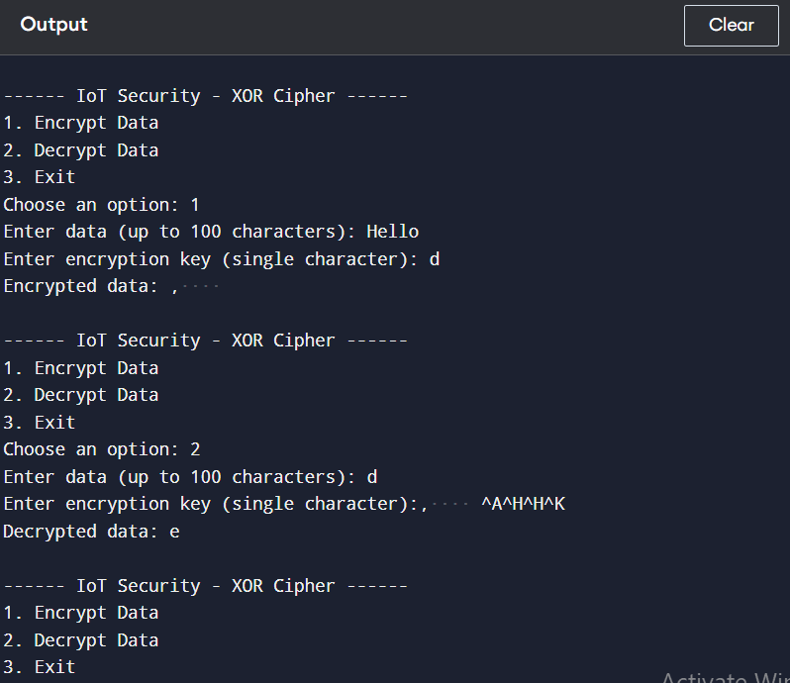

**OUTPUT 2**

------ IoT Security - XOR Cipher ------

1. Encrypt Data

2. Decrypt Data

3. Exit

Choose an option: 1

Enter data (up to 100 characters): Padmasri

Enter encryption key (single character): Q

Encrypted data: 05<0"#8

------ IoT Security - XOR Cipher ------

1. Encrypt Data

2. Decrypt Data

3. Exit

Choose an option: 2

Enter data (up to 100 characters): 05<0"#8^A05<0"#8

Enter encryption key (single character): Q

Decrypted data: Padmasri

------ IoT Security - XOR Cipher ------

1. Encrypt Data

2. Decrypt Data

3. Exit

Choose an option: 3

Exiting program...